**INFOLABZ IT SERVICES PVT. LTD.**

CUSTOM COMPONENTS :

app.js file

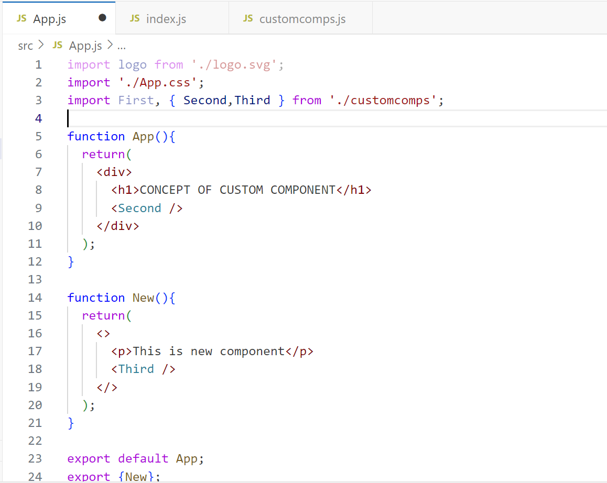

customcomps.js

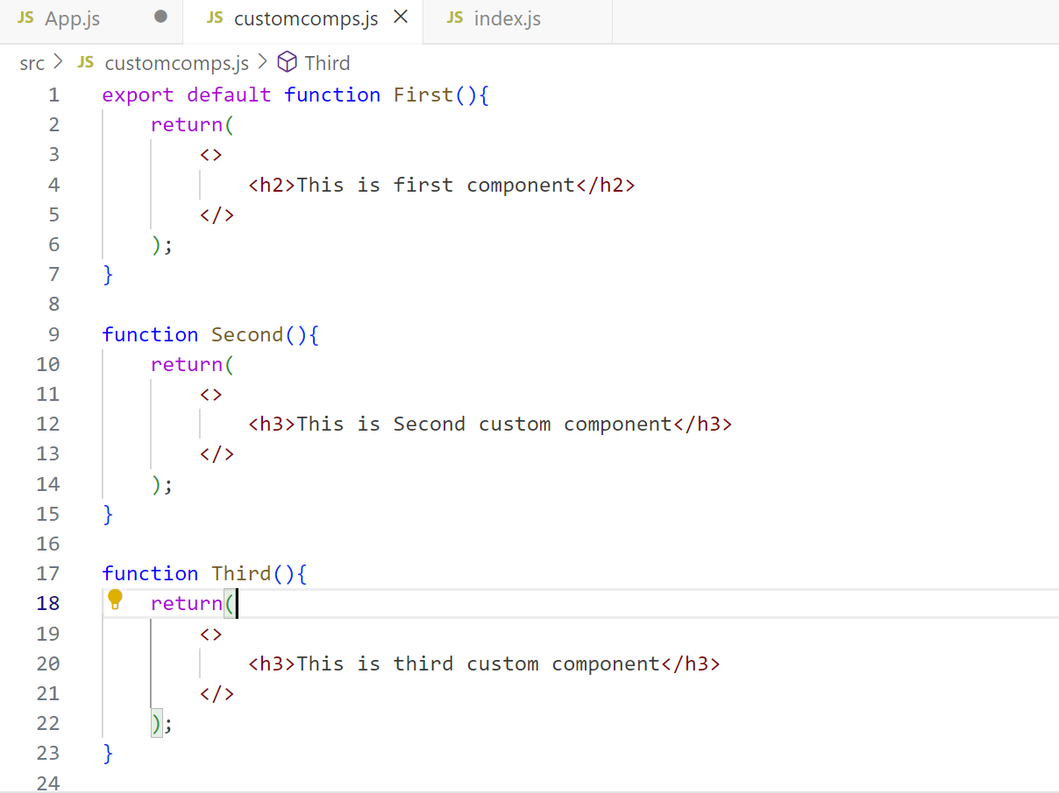

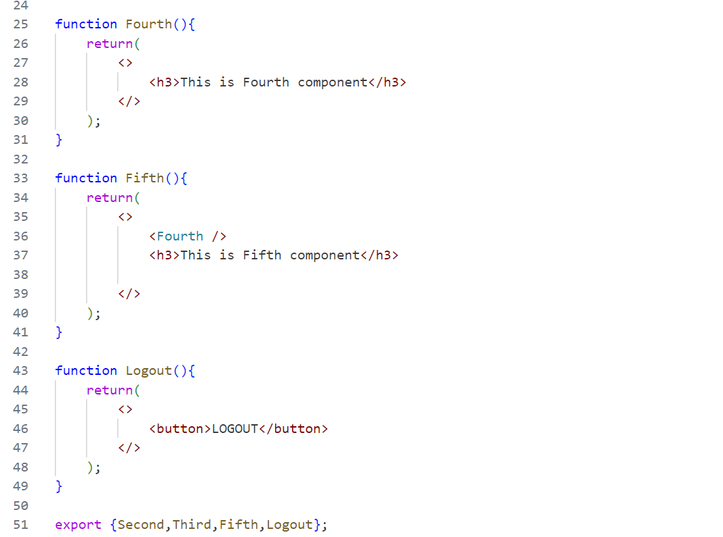

index.js

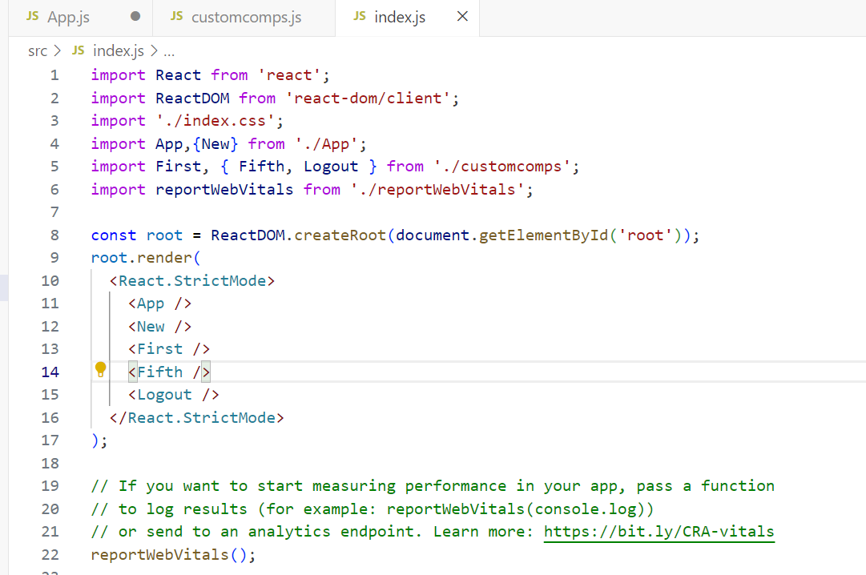

ADDING CSS TO COMPONENTS :

INLINE CASS

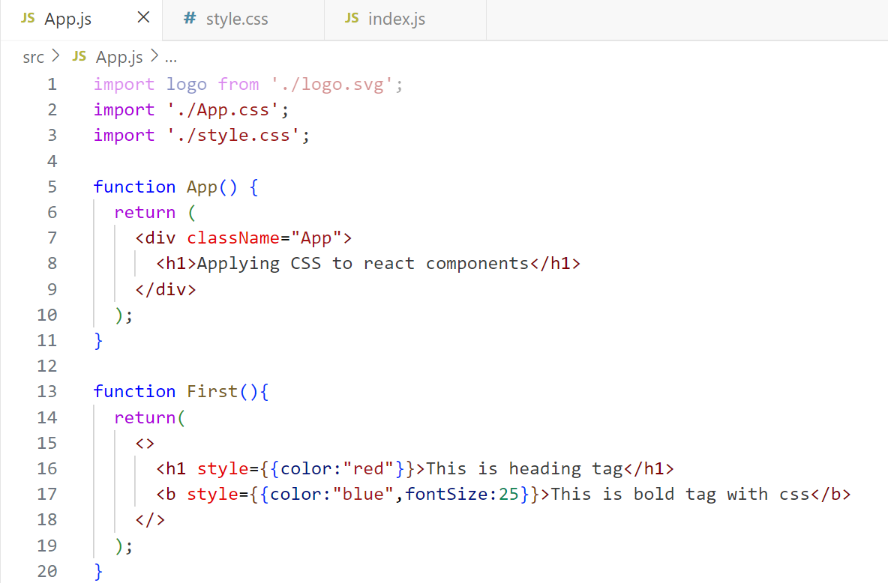

DOCUMENT LEVEL CSS

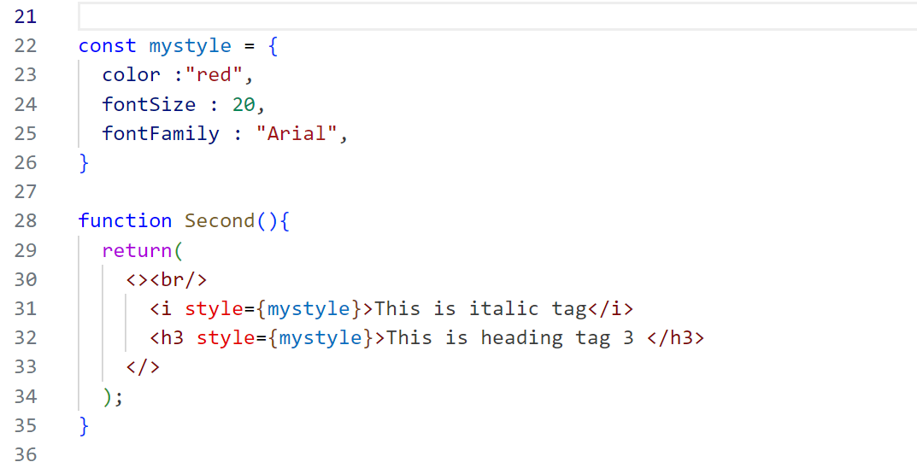

EXTERNAL CSS

CREATE style.css IN app.js folder

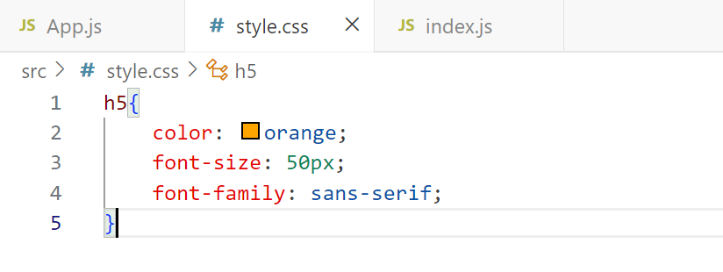

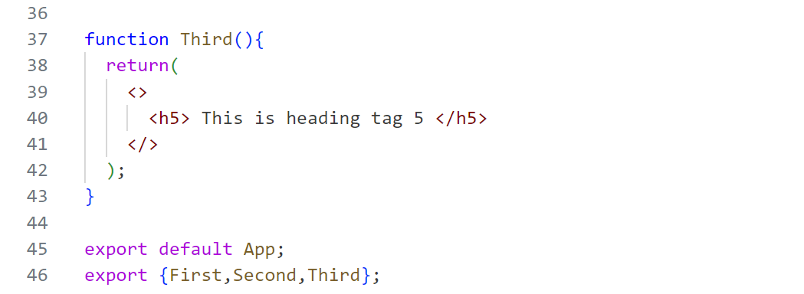

**TASKS**

1. **Dynamic API**

API : [http://universities.hipolabs.com/search?country=](http://universities.hipolabs.com/search?country=india){country_name}

FOR EXAMPLE : <http://universities.hipolabs.com/search?country=india>

Create a simple text form (html) which accepts country name from user. Pass country name in above API and print all universities in below format.

SR NO | UNIVERSITY NAME | STATE-PROVINCE | WEBSITE LINK

1 Ashoka University Haryana Visit Site

( on click of visit site, website should be open in new tab )

1. **Custom Components**

| **Create New react project : comppractice** | |
| --- | --- |
| **App.js** | App (DE), Msg(XE),New(XE), Practice(E) [Msg, New] |
| **custom.js** | Mycom(DE), Compone(E) [Second], Comptwo(XE), Add(E) [Comptwo,First, Notification, App] |
| **extra.js** | First(DE), Second(E), Third(E) [Comptow,Second,Login] |
| **practice.js** | Notification (DE) , Login (XE), Logout(E) [Login] |
| DE: export default , E : Export, XE : Not Export | |

1. **Add CSS as per your requirement in above components. ( CSS practice )**